example.R
carlislerainey
Fri Feb 15 05:56:04 2019
# R scrip to illustrate CA1
# load packages
library(tidyverse)
## ── Attaching packages ───────────────────────────────────────────────────────────────────────────── tidyverse 1.2.1 ──
## ✔ ggplot2 3.0.0 ✔ purrr 0.2.5
## ✔ tibble 1.4.2 ✔ dplyr 0.7.6
## ✔ tidyr 0.8.1 ✔ stringr 1.3.1
## ✔ readr 1.1.1 ✔ forcats 0.3.0
## ── Conflicts ──────────────────────────────────────────────────────────────────────────────── tidyverse_conflicts() ──
## ✖ dplyr::filter() masks stats::filter()
## ✖ dplyr::lag() masks stats::lag()
# load data
df <- read_rds("parties.rds")
# quick look
glimpse(df)
## Observations: 555
## Variables: 10
## $ country <chr> "Albania", "Albania", "Albania", "Argenti...
## $ year <dbl> 1992, 1996, 1997, 1946, 1951, 1954, 1958,...
## $ average_magnitude <dbl> 1.00, 1.00, 1.00, 10.53, 10.53, 4.56, 8.1...
## $ eneg <dbl> 1.106929, 1.106929, 1.106929, 1.342102, 1...
## $ enep <dbl> 2.190, 2.785, 2.870, 5.750, 1.970, 1.930,...
## $ upper_tier <dbl> 28.57, 17.86, 25.80, 0.00, 0.00, 0.00, 0....
## $ en_pres <dbl> 0.00, 0.00, 0.00, 2.09, 1.96, 1.96, 2.65,...
## $ proximity <dbl> 0.00, 0.00, 0.00, 1.00, 1.00, 0.20, 1.00,...
## $ social_heterogeneity <fct> Bottom 3rd of ENEG, Bottom 3rd of ENEG, B...
## $ electoral_system <fct> Single-Member District, Single-Member Dis...
# plot
ggplot(df, aes(x = electoral_system, y = enep)) +
geom_violin()
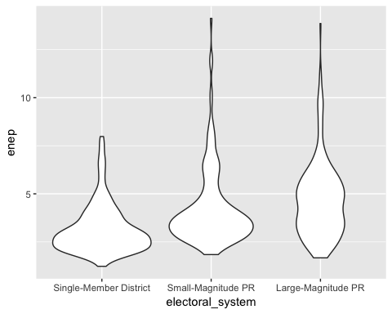
# observation 1: Just write your observations at the bottom of the script like
# this. If you want to "reflow" a script so that each line is the proper length
# without having to many enter the line breaks, just highlght the comment, and
# click *Code > Reflow Comment*. You'll get nice, equally-size lines, like
# these.
# observation 2: ...
# observation 3: ...

